DATA ANALYSIS DASHBOARD

CREATIVE AND INNOVATIVE PROJECT (CIP) REPORT
Batch 2023 (Semester VI)

SUBMITTED BY

P.Naga Phani Kumar
11239A074
S.Krishnama Naidu
11239A080

GUIDED BY
Mr.R.Manickavasagam
Internal Guide Name
Affliation and Designation



Department OF COMPUTER SCIENCE & ENGineering

SRI CHANDRASEKHARENDRA SARASWATHI VISWA MAHAVIDYALAYA

[April/May -2026]
Sri Chandrasekharendra Saraswathi Viswa Mahavidyalaya
Enathur, Kanchipuram – 631 561

BONAFIDE CERTIFICATE

This is to certify that the CIP Report entitled [……DATA ANALYSIS DASHBOARD…….]
is the bonafide work carried out by Mr. /Ms. …… P.Naga Phani Kumar &
S.Krishnama Naidu… Reg.No …11239A074…&…11239A080… during the academic year ------2023 -2027---.

[Internal Guide Name] [Head Name],
Designation, Head of the Department,
Department of CSE, Department of CSE,
SCSVMV. SCSVMV.

Submitted for the project work viva - voce examination held on _________________

Place : Kanchipuram.
Date :

Examiner 1 Examiner 2

DECLARATION

It is certified that the CIP work titled DATA ANALYSIS DASHBOARD
is originally implemented by me. No ideas, processes, results or words of others have been presented as my own work. Due acknowledgement is given wherever others' work or ideas are utilized.
- There is no fabrication of data or results which have been compiled /analyzed.
- There is no falsification by manipulating data or processes, or changing or omitting data or results.
I understand that the project is liable to be rejected at any stage (even at a later date) if it is discovered that the project has been plagiarized, or significant code has been copied. I understand that if such malpractices are found, the project will be disqualified, and the Degree awarded itself will become invalid.

Signature of the student with date

TABLE OF CONTENTS
Chapter | Title | Page No.
1 | INTRODUCTION | 6
 | 1.1 Introduction
 | 1.1.1 Importance of Data Analysis
 | 1.1.2 Types of Data
 | 1.1.3 Data Analysis Process
 | 1.2 Objectives
 | 1.3 Scope of the Project
 | 1.4 Existing System
 | 1.4.1 Comparison of Existing Systems
 | 1.5 Drawbacks of Existing System
2 | LITERATURE SURVEY | 16
 | 2.1 Literature Survey
 | 2.2 Problem Statement
 | 2.3 Research Gap
 | 2.4 Analysis of Paper
 | 2.4.1 Challenges in Data Analysis
3 | PROPOSED SYSTEM | 19
 | 3.1 System Overview
 | 3.1.1 Advantages of Proposed System
 | 3.2 Architecture
 | 3.2.1 Description of Components
 | 3.2.2 Data Flow Description
 | 3.2.3 Design Considerations
 | 3.3 Modules
 | 3.3.1 Detailed Module Description
 | 3.3.2 Data Structures Used
 | 3.3.3 Advantages of Modular Design
 | 3.4 Algorithm
 | 3.5 Methodology
 | 3.6 System Advantages
 | 3.7 System Limitations
4 | IMPLEMENTATION | 29
 | 4.1 Technologies Used
 | 4.1.1 Advantages of Technologies Used
 | 4.1.2 Software Requirements
 | 4.1.3 Hardware Requirements
 | 4.2 Code Explanation
 | 4.2.1 Sample Code Snippets
 | 4.2.2 Code Optimization Techniques
 | 4.2.3 Error Handling
 | 4.3 Testing
 | 4.3.1 Test Cases
 | 4.3.2 Performance Testing
 | 4.3.3 Usability Testing
 | 4.4 Experimental Results
 | 4.5 Result Analysis
 | 4.6 Performance Evaluation
5 | CONCLUSION | 41
 | 5.1 Future Enhancements
 | 5.2 Applications
 | 5.3 Advantages of System
 | 5.4 Limitations of System
 | 5.5 Future Scope
 | 5.6 System Architecture
 | 5.7 System Workflow
 | 5.8 Data Processing Techniques
 | 5.9 Visualization Techniques
 | 5.10 Performance Analysis
 | 5.11 Security Considerations
 | 5.12 Comparison with Existing Systems
 | 5.13 Real-World Use Cases
 | 5.14 User Experience Design
 | 5.15 Scalability Considerations
 | 5.16 Maintainability
 | 5.17 Testing and Validation
 | 5.18 Challenges Faced
 | 5.19 Learning Outcomes
 | 5.20 Conclusion
 | References | 48
Abstract

This project presents the design and development of an Auto Data Insights Dashboard using HTML, CSS, and JavaScript for efficient data analysis and visualization. The system enables users to upload CSV datasets and automatically performs data cleaning, statistical analysis, and visualization without the need for backend processing. The application identifies numeric and categorical data, removes duplicates, handles missing values, and generates meaningful insights.
The system integrates advanced features such as interactive filtering, automated insights generation, and multiple visualization techniques including bar charts, pie charts, line graphs, and geospatial maps. Additionally, a voice-based dataset generation feature is implemented using speech recognition technology, allowing users to create datasets dynamically. The application also supports exporting reports in PDF format and maintains dataset history using IndexedDB.
The proposed system simplifies the data analysis process and provides a user-friendly interface for beginners and non-technical users. It demonstrates how client-side technologies can effectively perform tasks traditionally handled by backend systems.
Keywords: Data Analysis, JavaScript, Data Visualization, CSV Processing, Data Cleaning

Chapter 1

Introduction

1.1 Introduction
In today’s digital world, data plays a crucial role in decision-making across various industries such as business, healthcare, education, and research. The rapid growth of data has created a need for efficient tools that can analyze and extract meaningful insights from large datasets. Traditional data analysis methods require technical expertise and specialized software, which may not be accessible to all users.
Most existing tools such as Excel, Python-based frameworks, and business intelligence platforms require either manual effort or programming knowledge. This creates a barrier for beginners who want to perform quick data analysis without learning complex tools.
To overcome these limitations, this project proposes a web-based Auto Data Insights Dashboard that performs data analysis entirely on the client side using JavaScript. The system allows users to upload CSV files, automatically clean the data, generate statistical summaries, and visualize the results using interactive charts.
The application is designed to be user-friendly and efficient, enabling users to analyze data without requiring backend infrastructure or advanced technical knowledge.

1.1.1 Importance of Data Analysis
Data analysis plays a significant role in modern decision-making processes across various industries. Organizations rely on data to understand customer behavior, optimize operations, and improve performance. In sectors such as banking, healthcare, education, and e-commerce, data analysis helps identify patterns, trends, and anomalies.
For example, in e-commerce platforms, data analysis is used to recommend products based on user preferences. In healthcare, it assists in diagnosing diseases and predicting patient outcomes. Similarly, in banking, it helps detect fraudulent transactions.
With the rapid increase in data generation, manual analysis has become inefficient and time-consuming. Automated data analysis tools are essential to process large volumes of data quickly and accurately. Therefore, developing user-friendly tools for data analysis is crucial in today’s digital world.

1.1.2 Types of Data
Data can be broadly classified into two categories:

1. Structured Data
Structured data is organized in a tabular format with rows and columns. It is easy to process and analyze. Examples include databases and spreadsheets.

2. Unstructured Data
Unstructured data does not follow a specific format. Examples include text documents, images, and videos. Processing such data requires advanced techniques.

3. Semi-Structured Data
This type of data lies between structured and unstructured formats. Examples include JSON and XML files.
Understanding data types is important for selecting appropriate processing techniques.

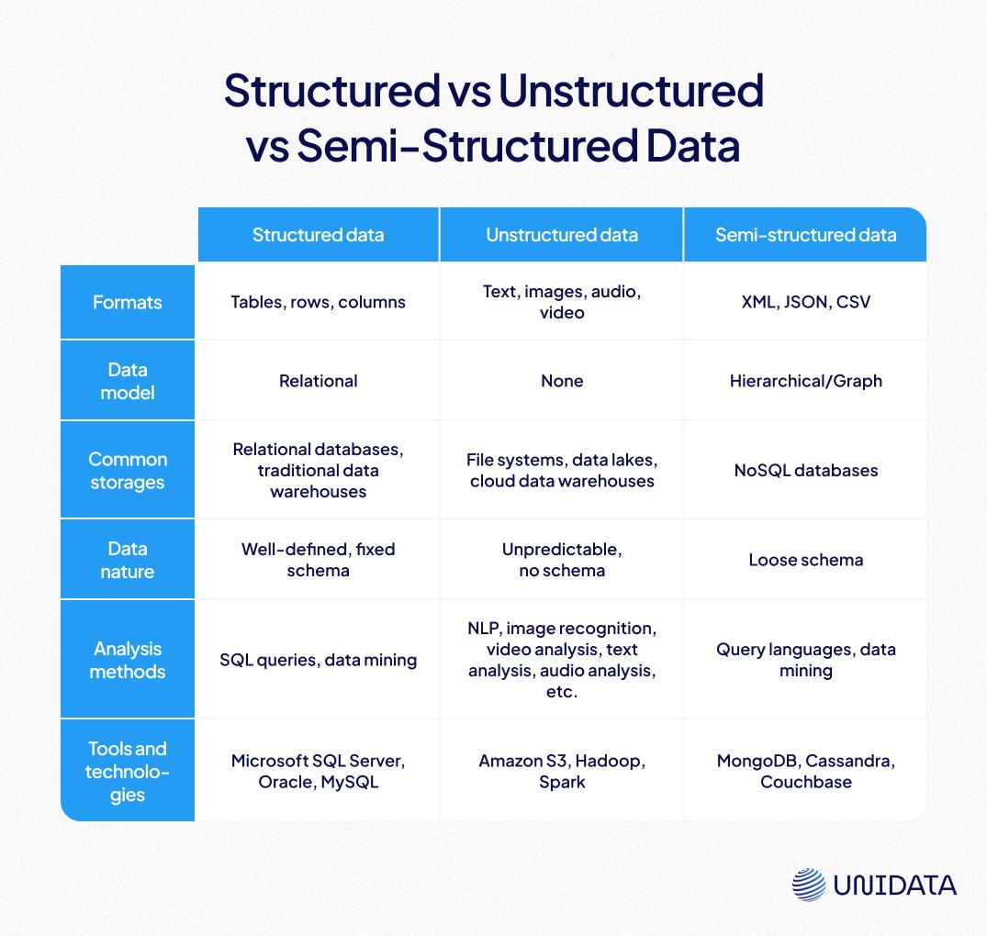

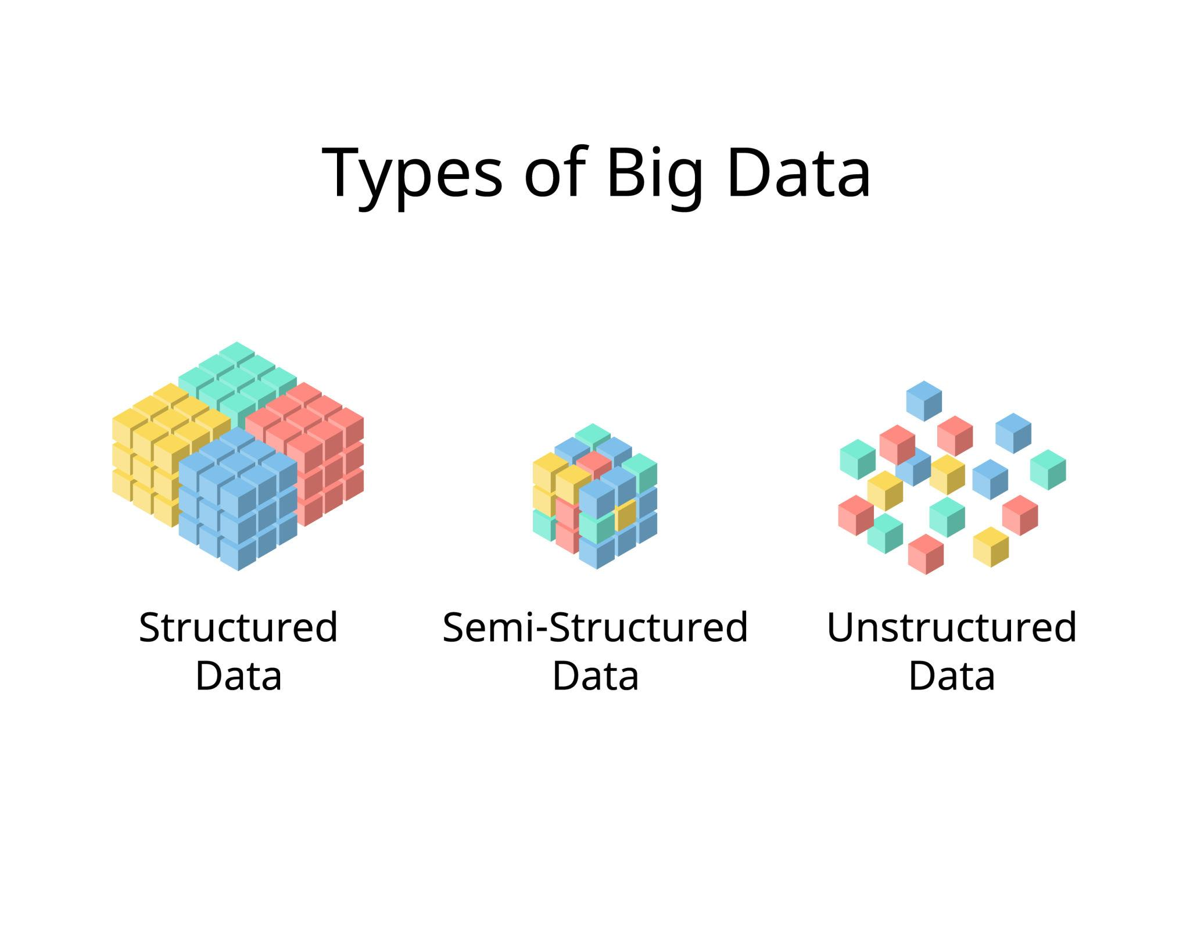

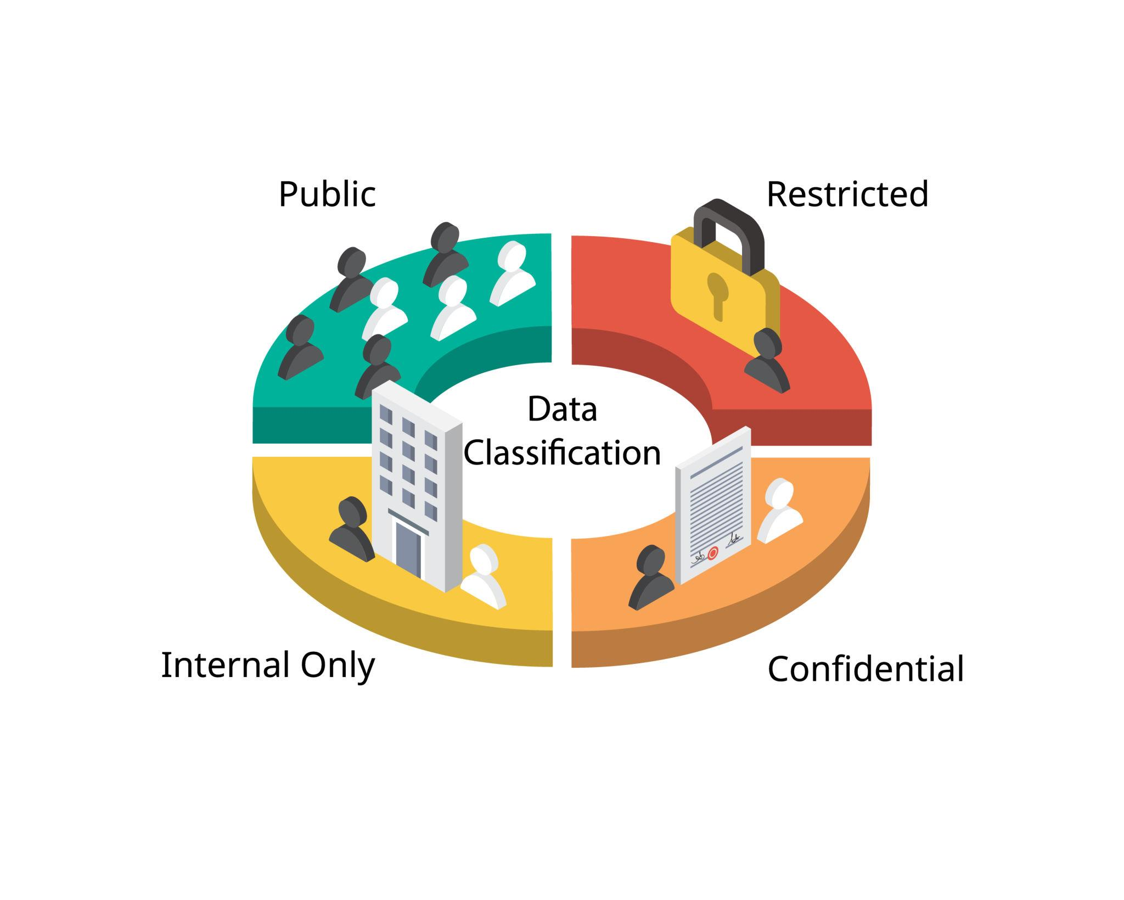

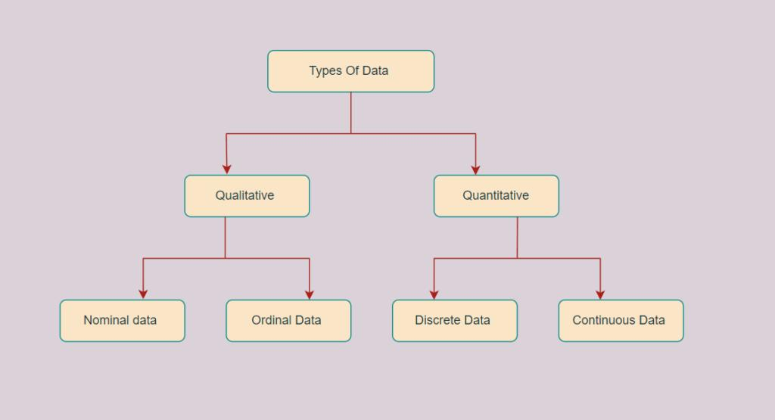

1.1.3 Data Analysis Process
The data analysis process consists of several steps:
- Data Collection
- Data Cleaning
- Data Transformation
- Data Analysis
- Data Visualization
Each step plays a crucial role in extracting meaningful insights.

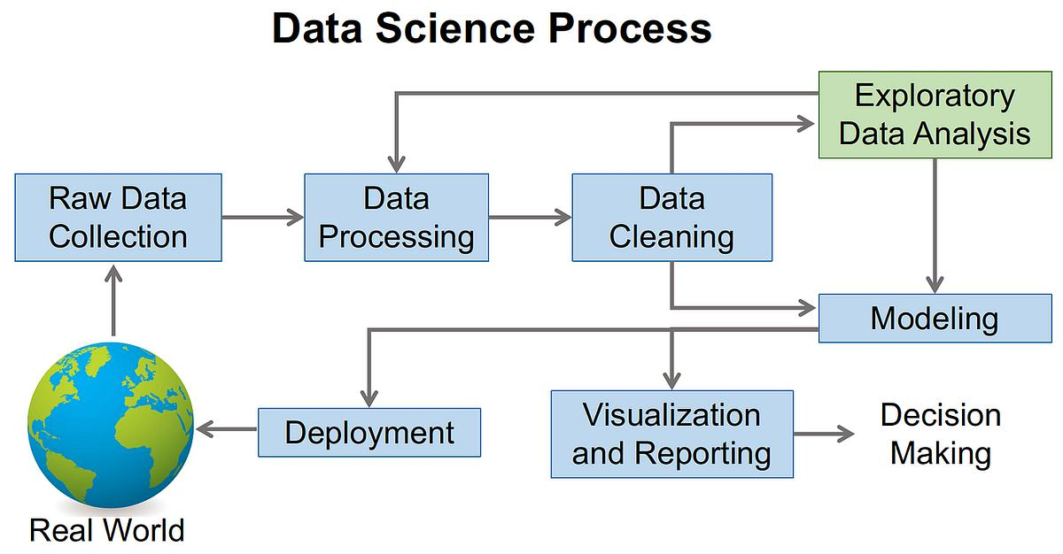

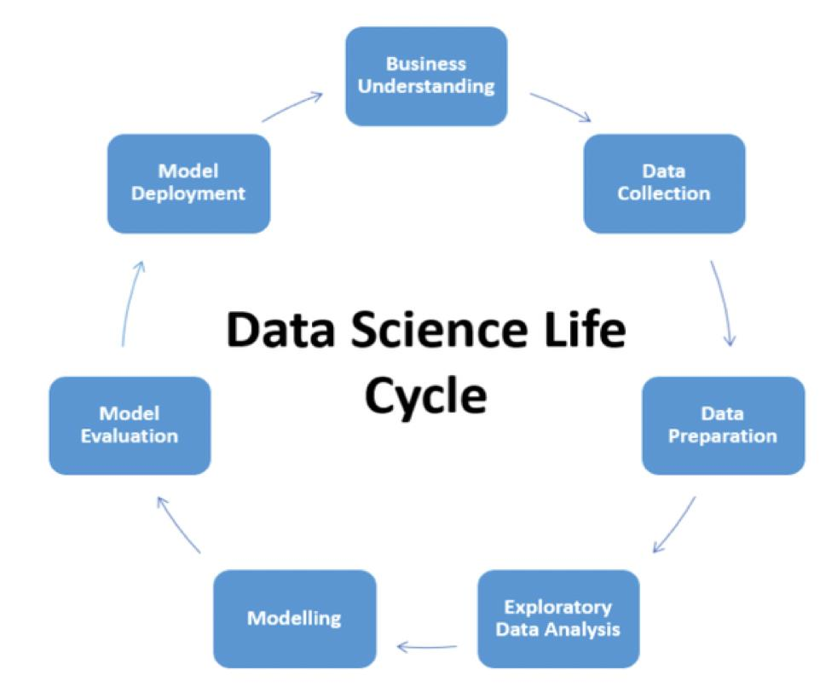

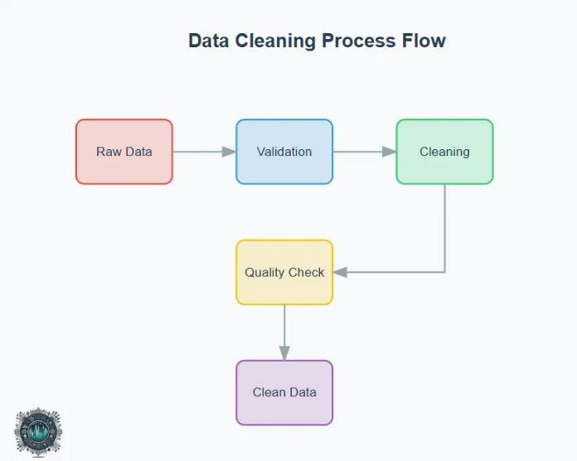

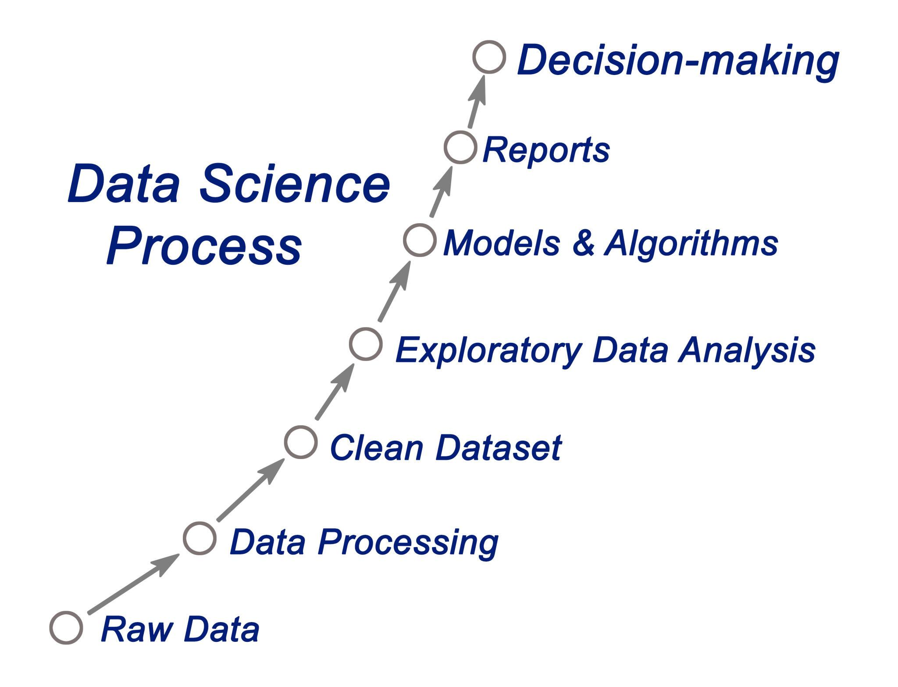

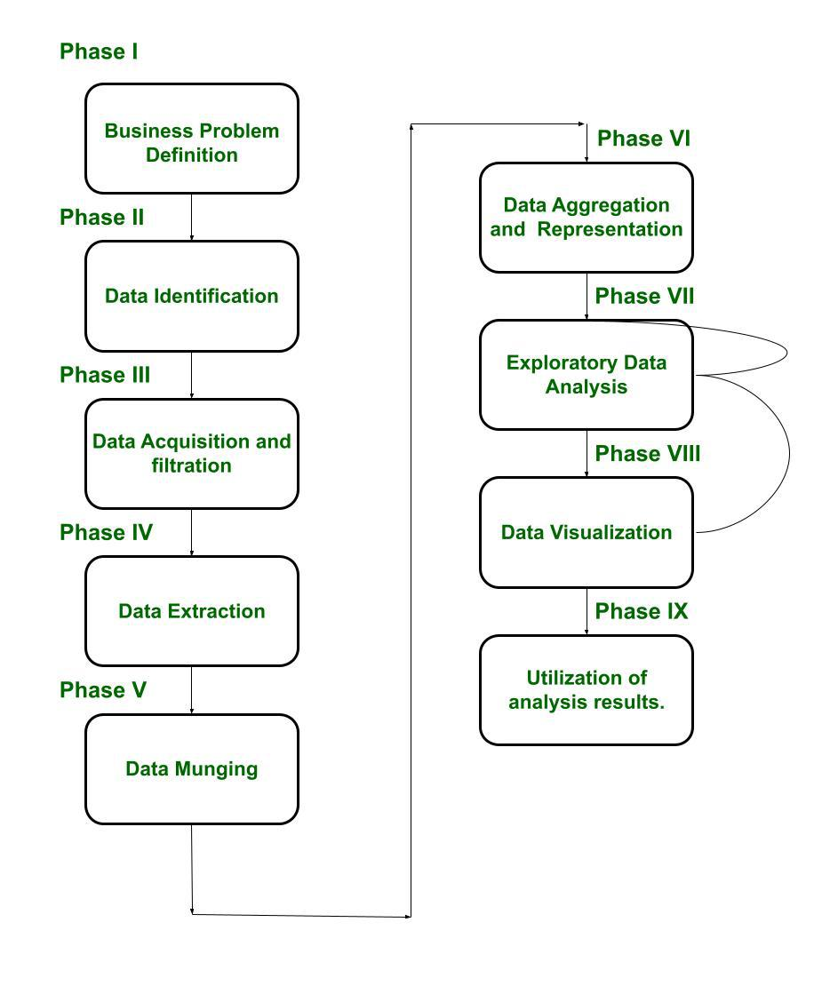

1.2 Objectives

The main objectives of the project are:
- To develop a web-based system for data analysis
- To automatically clean datasets by removing duplicates and missing values
- To generate statistical summaries such as mean, median, and range
- To provide interactive data visualization using charts
- To implement filtering and data wrangling techniques
- To enable voice-based dataset generation
- To provide report export functionality

1.3 Scope of the Project
The scope of this project includes:
- Processing CSV datasets using a web browser
- Providing real-time data analysis and visualization
- Supporting beginners and non-technical users
- Implementing client-side processing without backend
Limitations:
- Supports only CSV files
- Limited handling of very large datasets

1.4 Existing System
Existing systems for data analysis include:
- Microsoft Excel
  - Used for manual data analysis
  - Limited automation
- Python Libraries (Pandas, Matplotlib)
  - Powerful but requires coding knowledge
- Business Intelligence Tools (Power BI, Tableau)
  - Advanced features but complex and costly

1.4.1 Comparison of Existing Systems
Tool | Advantages | Disadvantages
Microsoft Excel | Easy to use, widely available | Manual work, limited automation
Python (Pandas, Matplotlib) | Powerful and flexible | Requires programming knowledge
Power BI / Tableau | Advanced visualization | Expensive and complex
The comparison shows that existing systems either require manual effort or technical expertise. This creates a need for a simple, automated solution.

1.5 Drawbacks of Existing System
- Requires technical knowledge
- Time-consuming manual operations
- Not beginner-friendly
- Requires software installation
- Lack of automation in basic tools

Chapter 2

Literature Survey

2.1 Literature Survey
Several research works have focused on data analysis and visualization systems.

Paper 1: Web-Based Data Visualization Systems (2023)
This paper discusses the development of browser-based visualization tools. It highlights the importance of real-time interaction and user-friendly interfaces. However, it lacks advanced data cleaning features.

Paper 2: Client-Side Data Processing using JavaScript (2024)
This research explains how JavaScript can be used for processing datasets without backend support. It demonstrates efficient handling of CSV data but does not include visualization modules.

Paper 3: Automated Data Cleaning Techniques (2023)
This paper focuses on removing missing values and duplicates automatically. It improves data quality but requires integration with other systems.

Paper 4: Interactive Dashboards for Data Analysis (2025)
This study presents dashboard systems with charts and KPIs. It provides good visualization but requires backend support.

2.2 Problem Statement
Existing data analysis tools either require programming knowledge or backend infrastructure. There is a need for a simple, browser-based system that allows users to upload datasets, clean data, and generate insights automatically without requiring coding skills.

2.3 Research Gap
From the literature survey, it is observed that most existing systems focus either on data visualization or data processing but do not combine both effectively in a simple user-friendly platform. Many tools require backend support or programming knowledge, making them unsuitable for beginners.
Additionally, existing systems lack features such as automatic data cleaning, real-time insights, and voice-based dataset generation. There is a clear gap in developing a lightweight, browser-based solution that integrates all these functionalities in a single platform.
The proposed system addresses these gaps by providing a complete data analysis solution using only client-side technologies.

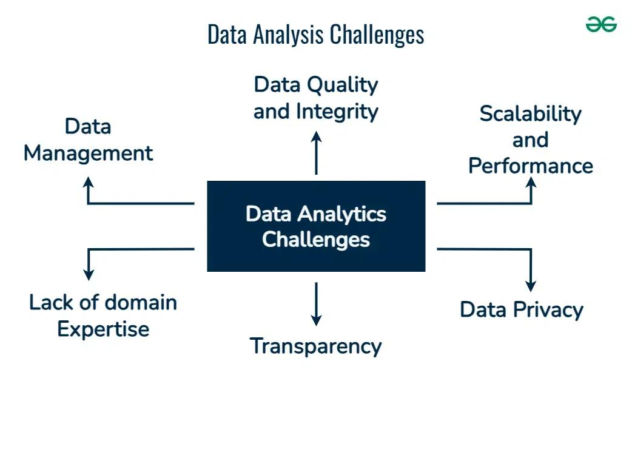

2.4 Analysis of Paper (Use after each paper)
The selected paper provides useful insights into data visualization techniques. However, it lacks automated data cleaning and real-time processing capabilities. The proposed system improves upon this by integrating both data cleaning and visualization in a single platform
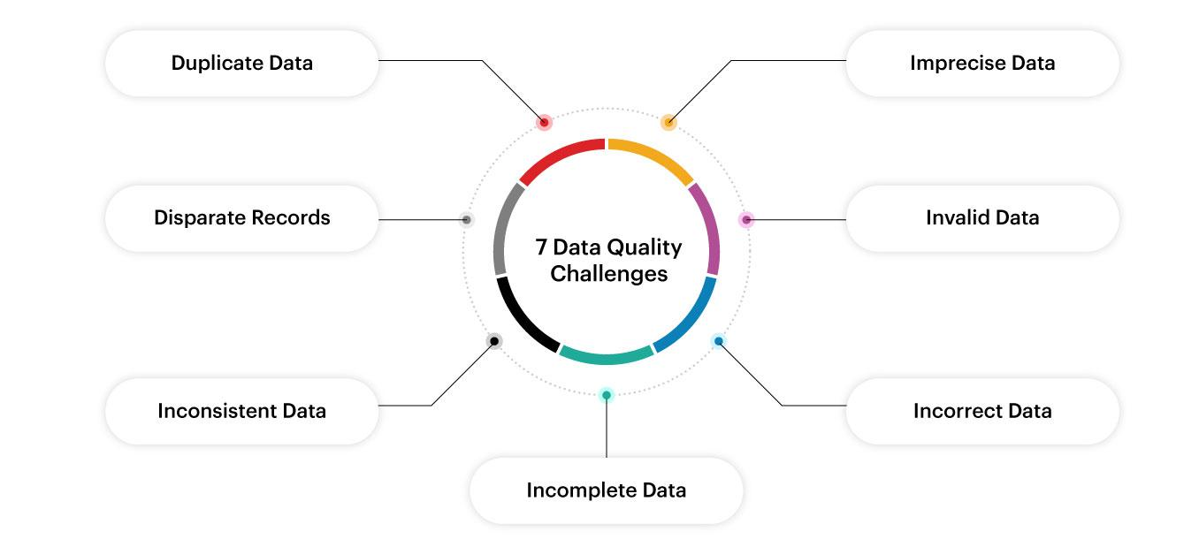

2.4.1 Challenges in Data Analysis
Data analysis faces several challenges:
- Handling missing data
- Dealing with large datasets
- Ensuring data accuracy
- Data integration from multiple sources
These challenges highlight the need for automated systems.
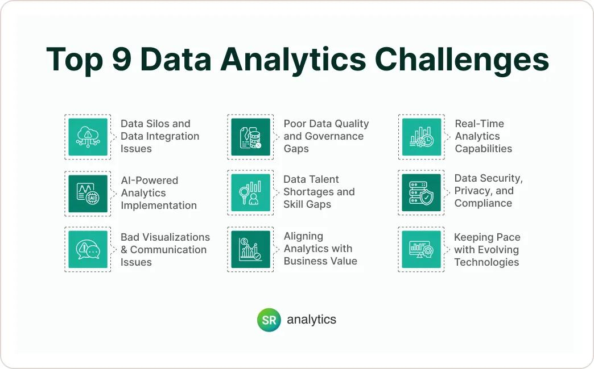

Chapter 3

Proposed Method / Algorithm / Architecture / Process / Methodology / Project Description

3.1 System Overview
The proposed system is a web-based dashboard that processes data entirely on the client side. The user uploads a dataset, and the system automatically performs cleaning, analysis, and visualization.

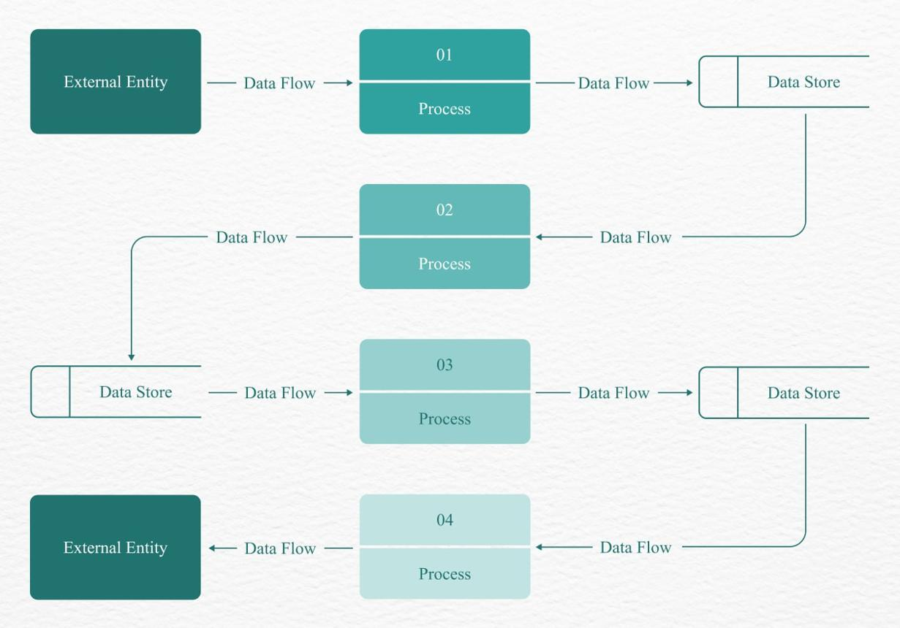

3.1.1 Advantages of Proposed System
The proposed system offers several advantages over traditional data analysis tools. It eliminates the need for backend infrastructure by performing all operations on the client side using JavaScript. This reduces system complexity and improves performance.
The system provides real-time data processing, allowing users to instantly view results after uploading datasets. It is user-friendly and does not require programming knowledge, making it suitable for beginners.
Additionally, the system includes advanced features such as automated insights, interactive filtering, and voice-based dataset generation, which enhance usability and functionality.

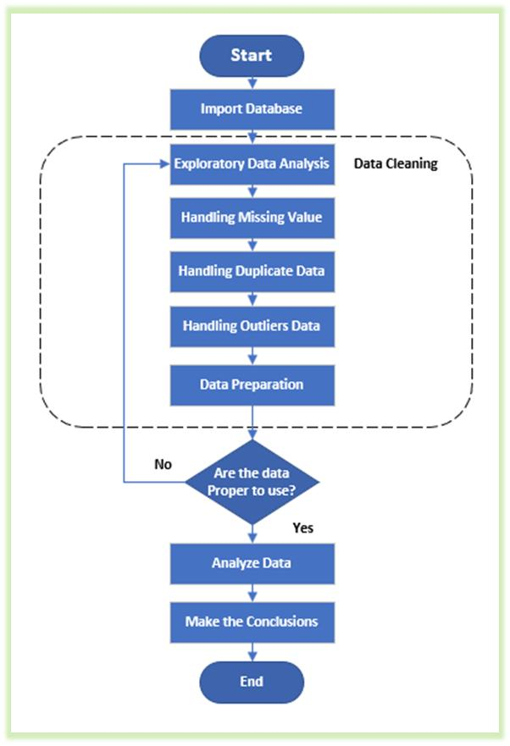

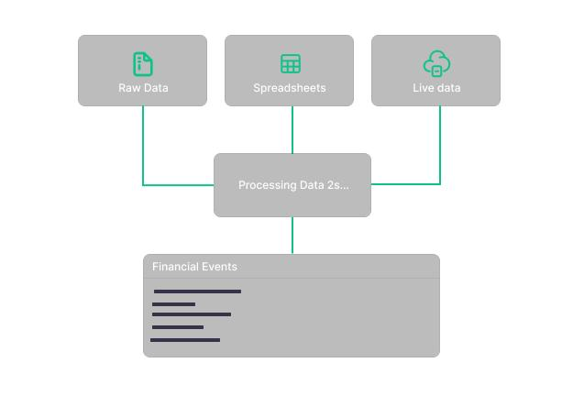
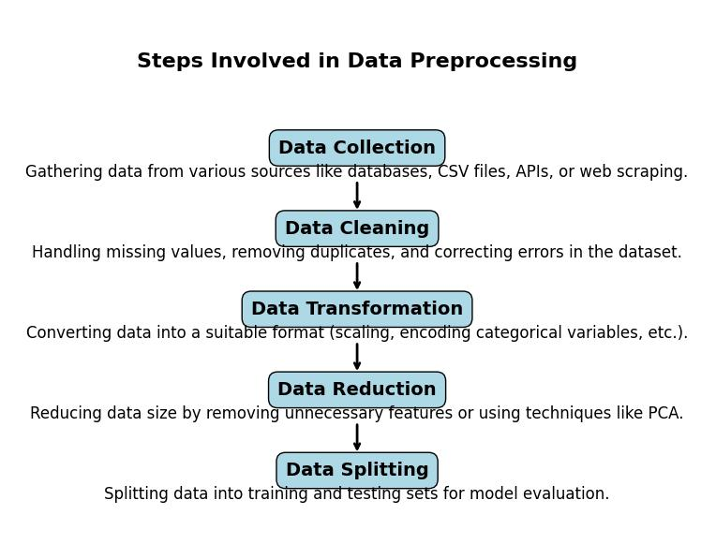

3.2 Architecture
The system consists of the following components:
- User Interface (HTML, CSS)
- Data Processing Engine (JavaScript)
- Visualization Module (Chart.js)
- Storage Module (IndexedDB)
Flow:
User → Upload CSV → Data Processing → Analysis → Visualization → Output
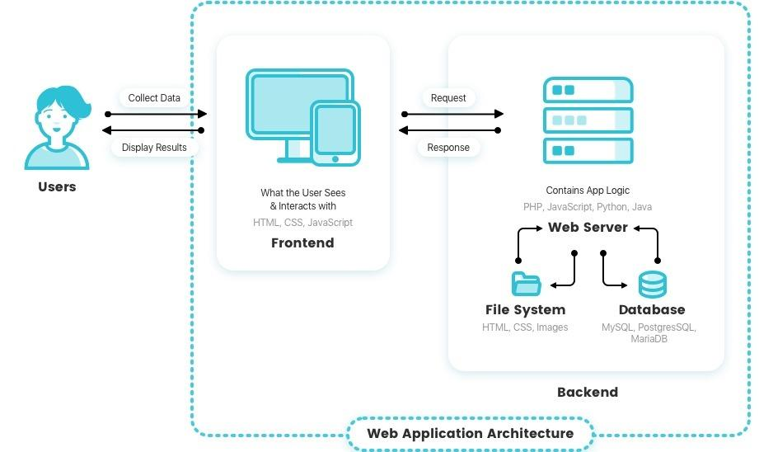

3.2.1 Description of Components
The system consists of several key components:
- User Interface: Developed using HTML and CSS, it provides an interactive and responsive design for users to upload and analyze data.
- JavaScript Engine: Acts as the core processing unit, handling data parsing, cleaning, and analysis.
- Modules: Includes upload, cleaning, analysis, visualization, and storage modules.
- Visualization Tools: Chart.js is used to generate graphs and charts.
- Storage: IndexedDB is used to store dataset history locally.
Each component plays an important role in ensuring smooth operation of the system.

3.2.2 Data Flow Description
The system follows a structured data flow:
- Input data is uploaded
- Data is parsed and validated
- Cleaning operations are applied
- Data is analyzed
- Results are visualized
This ensures efficient processing.

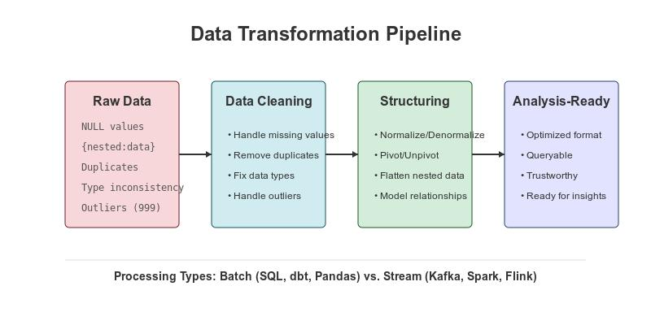

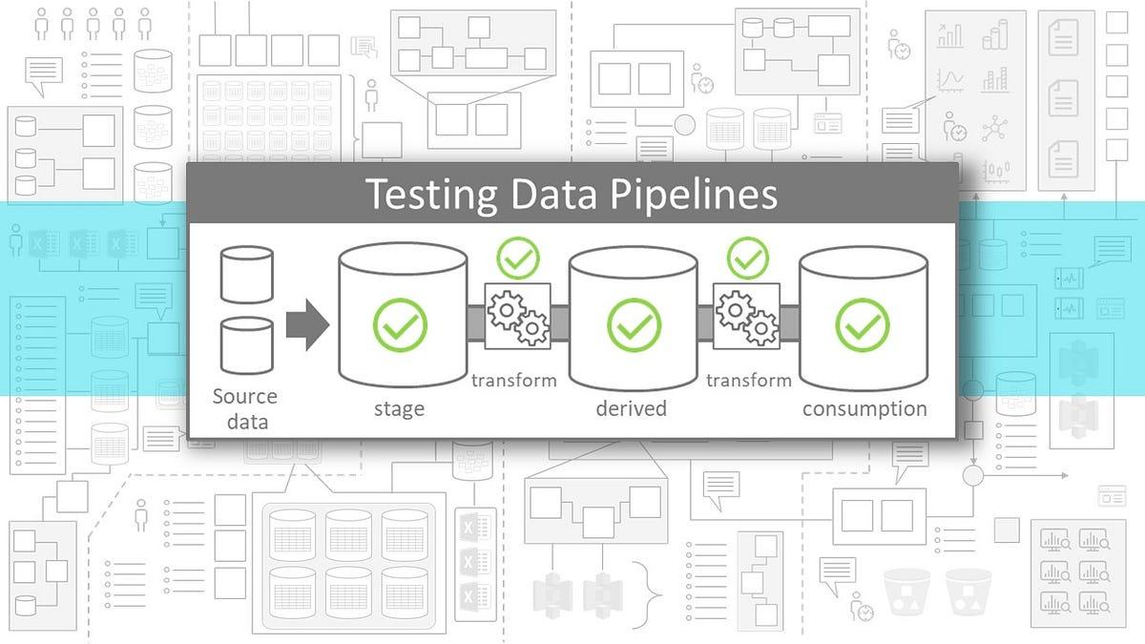

3.2.3 Design Considerations
The system is designed with the following considerations:
- Simplicity
- Performance
- Scalability
- User experience

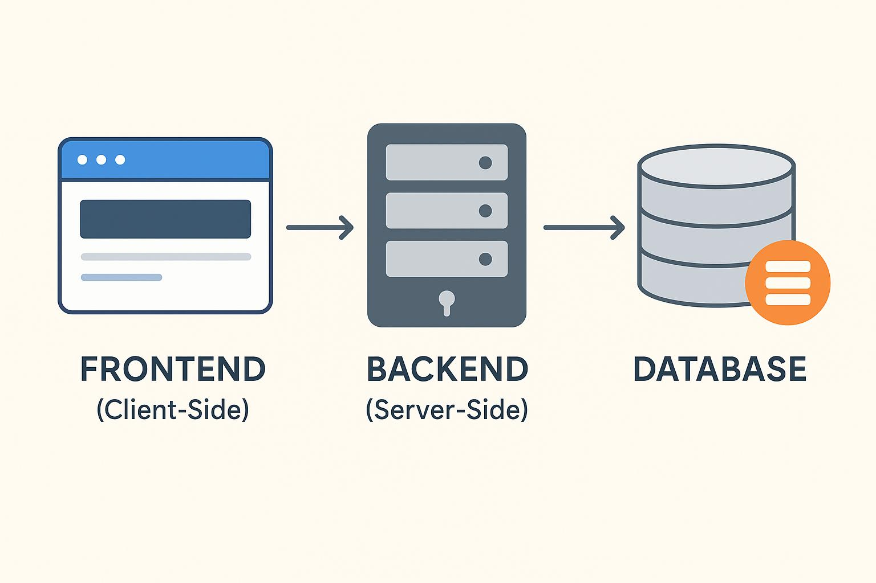

3.3 Modules

1. Data Upload Module

Allows users to upload CSV files using drag-and-drop or file selection.

2. Data Cleaning Module

Removes duplicates, empty rows, and trims text values.

3. Data Analysis Module

Calculates mean, median, minimum, maximum, and correlations.

4. Visualization Module

Generates charts such as bar charts, line graphs, and pie charts.

5. Data Wrangling Module

Applies filters and allows column removal.

6. Storage Module

Stores dataset history using IndexedDB.

7. Voice Module

Generates datasets using speech input.

3.3.1 Detailed Module Description

Data Upload Module
Handles file input and validation.

Data Cleaning Module
Removes inconsistencies and improves data quality.

Data Analysis Module
Performs statistical calculations.

Visualization Module
Displays data using charts.

3.3.2 Data Structures Used
The system uses:
- Arrays
- Objects
- JSON structures

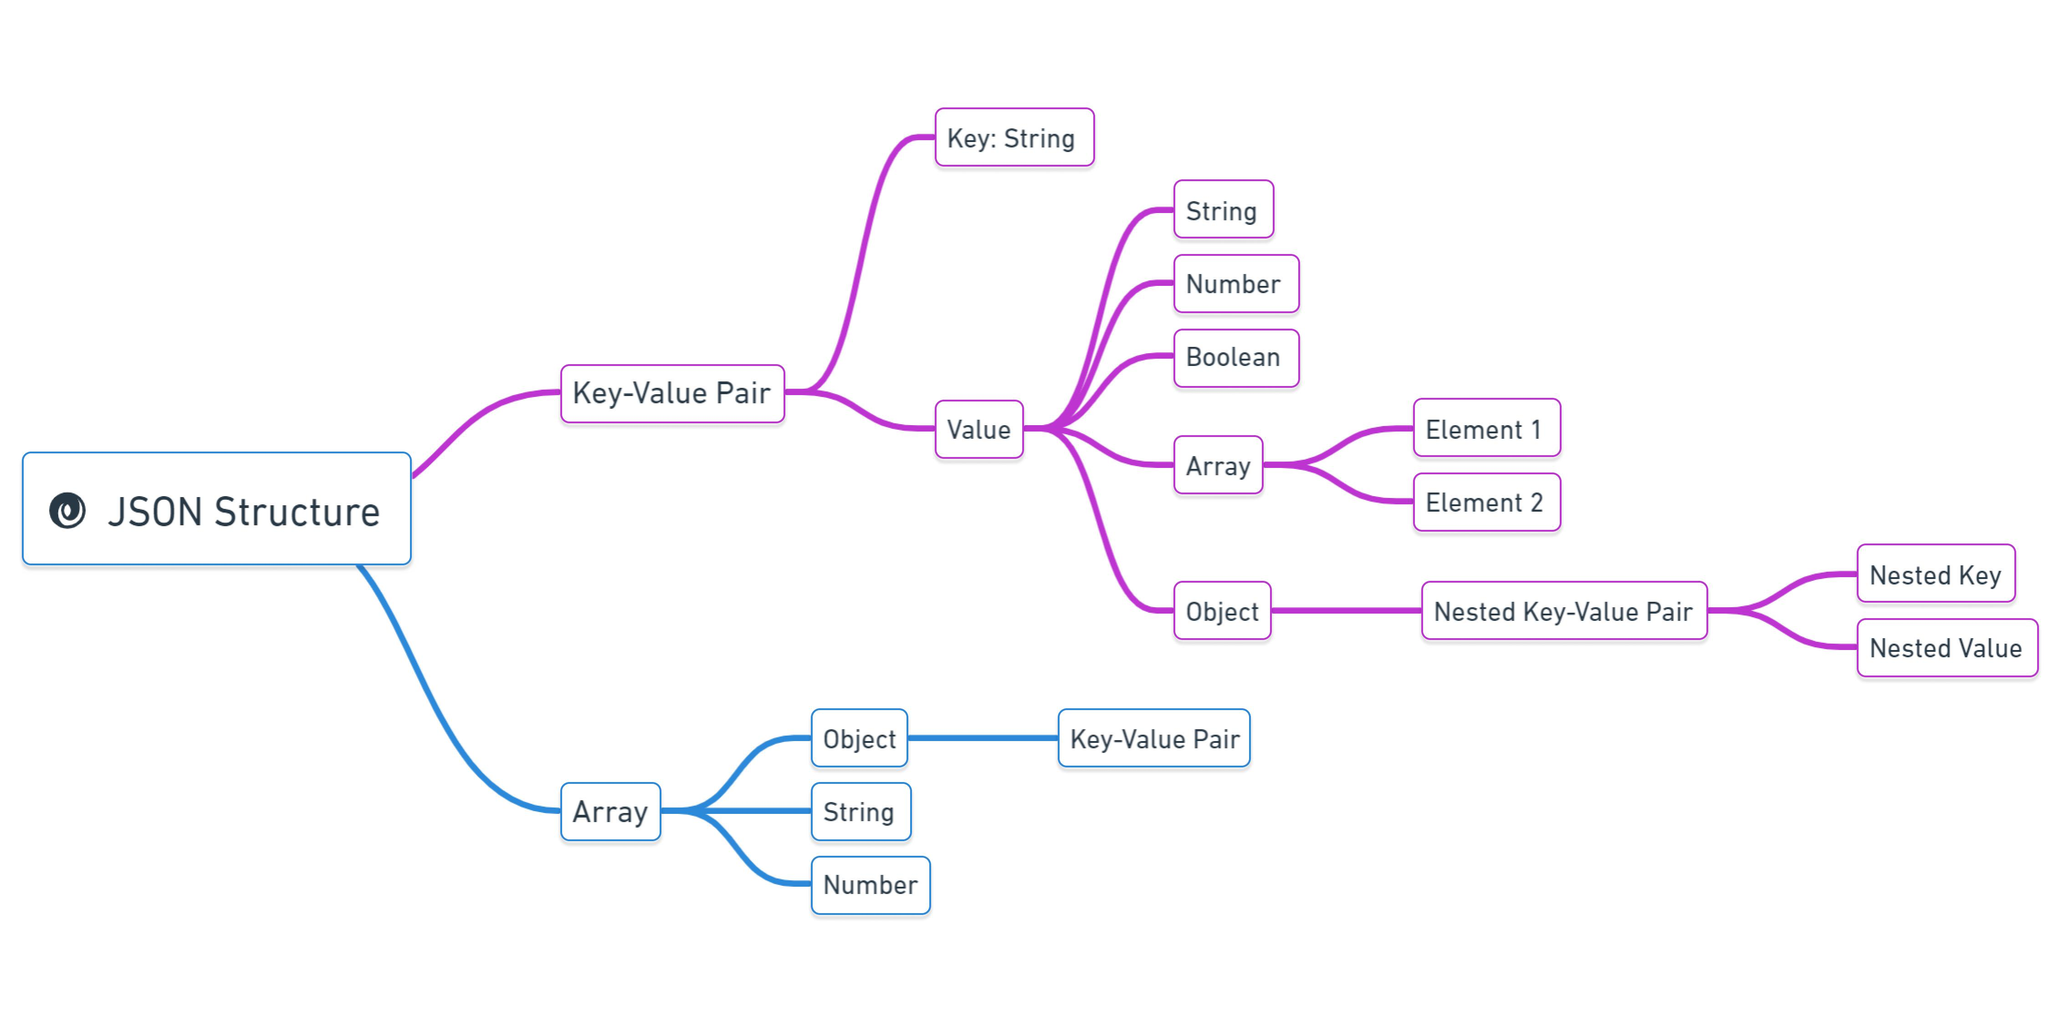

These structures help in efficient data manipulation.

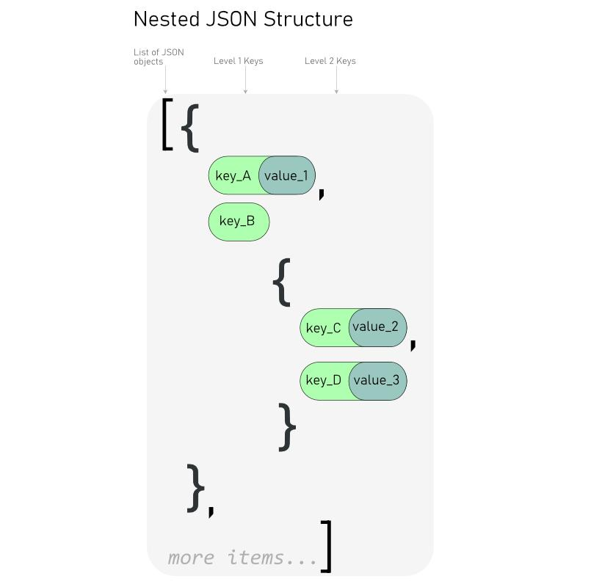

3.3.3 Advantages of Modular Design
- Easy maintenance
- Better scalability
- Improved readability

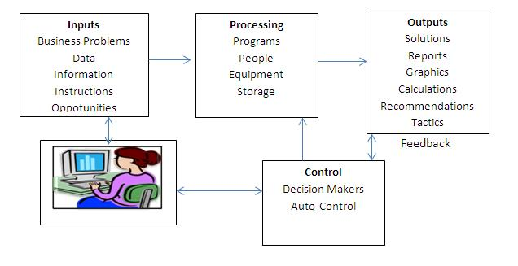

3.4 Algorithm
Step 1: Upload CSV file
Step 2: Parse data
Step 3: Identify column types
Step 4: Clean data
Step 5: Apply filters
Step 6: Generate statistics
Step 7: Visualize data

3.5 Methodology
The system uses client-side technologies to perform all operations. JavaScript acts as both frontend and backend logic, enabling real-time processing and reducing system complexity.

3.6 System Advantages
- No backend required
- Real-time data processing
- User-friendly interface
- Automatic data cleaning
- Interactive visualizations
- Voice-based dataset generation

3.7 System Limitations
- Supports only CSV files
- Limited performance for very large datasets
- Requires modern browser support
- Voice feature depends on browser compatibility

Chapter 4

Implementation / Code / Testing methodologies/ Experimental graphs/ Results and Description of Results

4.1 Technologies Used
- HTML – Structure
- CSS – Styling and themes
- JavaScript – Logic and processing
- Chart.js – Visualization
- PapaParse – CSV parsing
- Leaflet – Maps
- JsPDF – Report generation

4.1.1 Advantages of Technologies Used
The technologies used in this project provide several advantages:
- HTML & CSS: Enable structured and responsive design
- JavaScript: Provides dynamic functionality and client-side processing
- Chart.js: Allows creation of interactive and visually appealing charts
- PapaParse: Efficiently parses CSV files
- Leaflet: Supports geospatial visualization
- jsPDF: Enables report generation
These technologies work together to create a powerful and efficient system.

4.1.2 Software Requirements
- Operating System: Windows/Linux
- Browser: Chrome/Edge
- Tools: VS Code

4.1.3 Hardware Requirements
- Processor: Intel i3 or above
- RAM: 4GB minimum
- Storage: 500MB

4.2 Code Explanation
- File upload using input and drag-and-drop
- Data parsing using PapaParse
- Filtering using conditions
- Auto-cleaning for missing values
- Chart generation using Chart.js
HTML Code:-

<!DOCTYPE html>
<html lang="en" data-theme="neon">
<head>
<meta charset="UTF-8">
<meta name="viewport" content="width=device-width, initial-scale=1.0">
<title>Data Insights Pro</title>

<!-- Fonts & Libraries -->
<link rel="preconnect" href="https://fonts.googleapis.com">
<link href="https://fonts.googleapis.com/css2?family=Outfit:wght@300;600&display=swap" rel="stylesheet">
<link rel="stylesheet" href="https://unpkg.com/leaflet@1.9.4/dist/leaflet.css"/>
<script src="https://unpkg.com/lucide@latest"></script>
<script src="https://cdnjs.cloudflare.com/ajax/libs/PapaParse/5.4.1/papaparse.min.js"></script>
<script src="https://cdn.jsdelivr.net/npm/chart.js"></script>
<script src="https://cdn.jsdelivr.net/npm/chartjs-plugin-zoom@2.0.1"></script>
<script src="https://cdnjs.cloudflare.com/ajax/libs/jspdf/2.5.1/jspdf.umd.min.js"></script>
<script src="https://cdnjs.cloudflare.com/ajax/libs/html2canvas/1.4.1/html2canvas.min.js"></script>
<script src="https://unpkg.com/leaflet@1.9.4/dist/leaflet.js"></script>

<link rel="stylesheet" href="styles.css">
</head>

<body>
<div class="background-blur"></div>

<!-- NAV -->
<nav class="app-nav glass-panel">
<div class="nav-brand">
<i data-lucide="orbit"></i>
<h2>Data Insights <span class="badge">PRO</span></h2>
</div>

<ul class="nav-links">
<li><button class="nav-btn active" data-target="view-dashboard">Dashboard</button></li>
<li><button class="nav-btn" data-target="view-wrangling">Wrangling</button></li>
<li><button class="nav-btn" data-target="view-visualizations">Visuals</button></li>
<li><button class="nav-btn" data-target="view-history">History</button></li>
</ul>

<select id="theme-select" class="dropdown">
<option>Light</option><option>Dark</option>
<option>Modern</option><option selected>Neon</option>
</select>
</nav>

<div class="app-container">

<!-- DASHBOARD -->
<main id="view-dashboard" class="view-section active">

<header class="app-header">
<h1>Data Engine</h1>
<p>Upload CSV to generate insights</p>
</header>

<section id="upload-section" class="upload-section glass-panel">
<div id="drop-zone">
<i data-lucide="upload-cloud"></i>
<h2>Upload CSV</h2>
<label class="btn btn-primary">
Browse <input type="file" id="file-input" accept=".csv" hidden>
</label>

<button id="voice-dataset-btn" class="btn btn-secondary">
🎤 Voice Dataset
</button>
</div>
</section>

<div id="loading-state" class="hidden">
<p>Processing...</p>
</div>

<div id="dashboard-results" class="hidden">

<div class="flex-between">
<h2 id="current-file-display">dataset.csv</h2>
<div>
<button id="auto-clean-btn">Clean</button>
<button id="export-pdf-btn">PDF</button>
<button id="export-btn">CSV</button>
</div>
</div>

<!-- OVERVIEW -->
<div class="grid-row-2">

<div class="card">
<h3>Overview</h3>
<p>Rows: <span id="val-rows"></span></p>
<p>Cols: <span id="val-cols"></span></p>
</div>

<div class="card">
<h3>Insights</h3>
<ul id="insights-list"></ul>
</div>

</div>

<!-- STATS -->
<table id="stats-table">
<thead>
<tr><th>Col</th><th>Mean</th><th>Median</th></tr>
</thead>
<tbody id="stats-body"></tbody>
</table>

</div>
</main>

<!-- WRANGLING -->
<main id="view-wrangling" class="view-section hidden">
<h2>Wrangling</h2>
<select id="wrangl-drop-col"></select>
<button id="btn-drop-col">Drop</button>
</main>

<!-- VISUALIZATION -->
<main id="view-visualizations" class="view-section hidden">
<h2>Charts</h2>

<select id="viz-type">
<option>bar</option><option>line</option><option>pie</option>
</select>

<select id="viz-x"></select>
<button id="viz-update-btn">Render</button>

<canvas id="advanced-chart"></canvas>
<div id="map-container" class="hidden"></div>

</main>

<!-- HISTORY -->
<main id="view-history" class="view-section hidden">
<h2>History</h2>
<div id="history-list"></div>
</main>

</div>

<script src="app.js"></script>
</body>
</html>

JS code:-

<!DOCTYPE html>
<html lang="en" data-theme="neon">

<head>
<meta charset="UTF-8">
<meta name="viewport" content="width=device-width, initial-scale=1.0">
<title>Data Insights Pro</title>

<!-- Google Fonts -->
<link rel="preconnect" href="https://fonts.googleapis.com">
<link href="https://fonts.googleapis.com/css2?family=Outfit:wght@300;600&display=swap" rel="stylesheet">

<!-- Styles -->
<link rel="stylesheet" href="styles.css">
<link rel="stylesheet" href="https://unpkg.com/leaflet@1.9.4/dist/leaflet.css"/>

<!-- Libraries -->
<script src="https://unpkg.com/lucide@latest"></script>
<script src="https://cdnjs.cloudflare.com/ajax/libs/PapaParse/5.4.1/papaparse.min.js"></script>
<script src="https://cdn.jsdelivr.net/npm/chart.js"></script>
<script src="https://cdn.jsdelivr.net/npm/chartjs-plugin-zoom@2.0.1"></script>
<script src="https://cdnjs.cloudflare.com/ajax/libs/jspdf/2.5.1/jspdf.umd.min.js"></script>
<script src="https://cdnjs.cloudflare.com/ajax/libs/html2canvas/1.4.1/html2canvas.min.js"></script>
<script src="https://unpkg.com/leaflet@1.9.4/dist/leaflet.js"></script>
</head>

<body>

<!-- Background Effect -->
<div class="background-blur"></div>

<!-- ================= NAVBAR ================= -->
<nav class="app-nav glass-panel">

<div class="nav-brand">
<i data-lucide="orbit"></i>
<h2>Data Insights <span class="badge">PRO</span></h2>
</div>

<ul class="nav-links">
<li><button class="nav-btn active" data-target="view-dashboard">Dashboard</button></li>
<li><button class="nav-btn" data-target="view-wrangling">Wrangling</button></li>
<li><button class="nav-btn" data-target="view-visualizations">Visuals</button></li>
<li><button class="nav-btn" data-target="view-history">History</button></li>
</ul>

<!-- Theme Selector -->
<select id="theme-select" class="dropdown">
<option>Light</option>
<option>Dark</option>
<option>Modern</option>
<option selected>Neon</option>
</select>

</nav>

<!-- ================= MAIN CONTAINER ================= -->
<div class="app-container">

<!-- ========= DASHBOARD ========= -->
<main id="view-dashboard" class="view-section active">

<header class="app-header">
<h1>Data Engine</h1>
<p>Upload CSV to generate insights</p>
</header>

<!-- Upload Section -->
<section id="upload-section" class="upload-section glass-panel">
<div id="drop-zone">
<i data-lucide="upload-cloud"></i>
<h2>Upload CSV</h2>

<label class="btn btn-primary">
Browse
<input type="file" id="file-input" accept=".csv" hidden>
</label>

<button id="voice-dataset-btn" class="btn btn-secondary">
🎤 Voice Dataset
</button>
</div>
</section>

<!-- Loading -->
<div id="loading-state" class="hidden">
<p>Processing...</p>
</div>

<!-- Results -->
<div id="dashboard-results" class="hidden">

<div class="flex-between">
<h2 id="current-file-display">dataset.csv</h2>

<div>
<button id="auto-clean-btn">Clean</button>
<button id="export-pdf-btn">PDF</button>
<button id="export-btn">CSV</button>
</div>
</div>

<!-- Overview + Insights -->
<div class="grid-row-2">

<div class="card">
<h3>Overview</h3>
<p>Rows: <span id="val-rows"></span></p>
<p>Cols: <span id="val-cols"></span></p>
</div>

<div class="card">
<h3>Insights</h3>
<ul id="insights-list"></ul>
</div>

</div>

<!-- Stats Table -->
<table id="stats-table">
<thead>
<tr>
<th>Column</th>
<th>Mean</th>
<th>Median</th>
</tr>
</thead>
<tbody id="stats-body"></tbody>
</table>

</div>
</main>

<!-- ========= WRANGLING ========= -->
<main id="view-wrangling" class="view-section hidden">
<h2>Data Wrangling</h2>

<select id="wrangl-drop-col"></select>
<button id="btn-drop-col">Drop Column</button>
</main>

<!-- ========= VISUALIZATION ========= -->
<main id="view-visualizations" class="view-section hidden">
<h2>Charts</h2>

<select id="viz-type">
<option>bar</option>
<option>line</option>
<option>pie</option>
</select>

<select id="viz-x"></select>
<button id="viz-update-btn">Render Chart</button>

<canvas id="advanced-chart"></canvas>
<div id="map-container" class="hidden"></div>
</main>

<!-- ========= HISTORY ========= -->
<main id="view-history" class="view-section hidden">
<h2>History</h2>
<div id="history-list"></div>
</main>

</div>

<!-- Main Script -->
<script src="app.js"></script>

</body>
</html>

4.2.1 Sample Code Snippets

CSV Parsing Example
Papa.parse(file, {
header: true,
complete: function(results) {
console.log(results.data);
}
});

Filtering Logic
data.filter(row => row.value > 50);

Chart Generation
new Chart(ctx, {
type: 'bar',
data: {
labels: labels,
datasets: [{
data: values
}]
}
});

4.2.2 Code Optimization Techniques
The system uses efficient coding practices such as:
- Avoiding redundant loops
- Using optimized data structures
- Minimizing memory usage

4.2.3 Error Handling
The system handles errors such as:
- Invalid file formats
- Missing values
- Incorrect inputs

4.3 Testing
The system was tested with multiple datasets to ensure:
- Correct parsing of CSV files
- Proper handling of missing values
- Accurate visualization
- Responsive UI
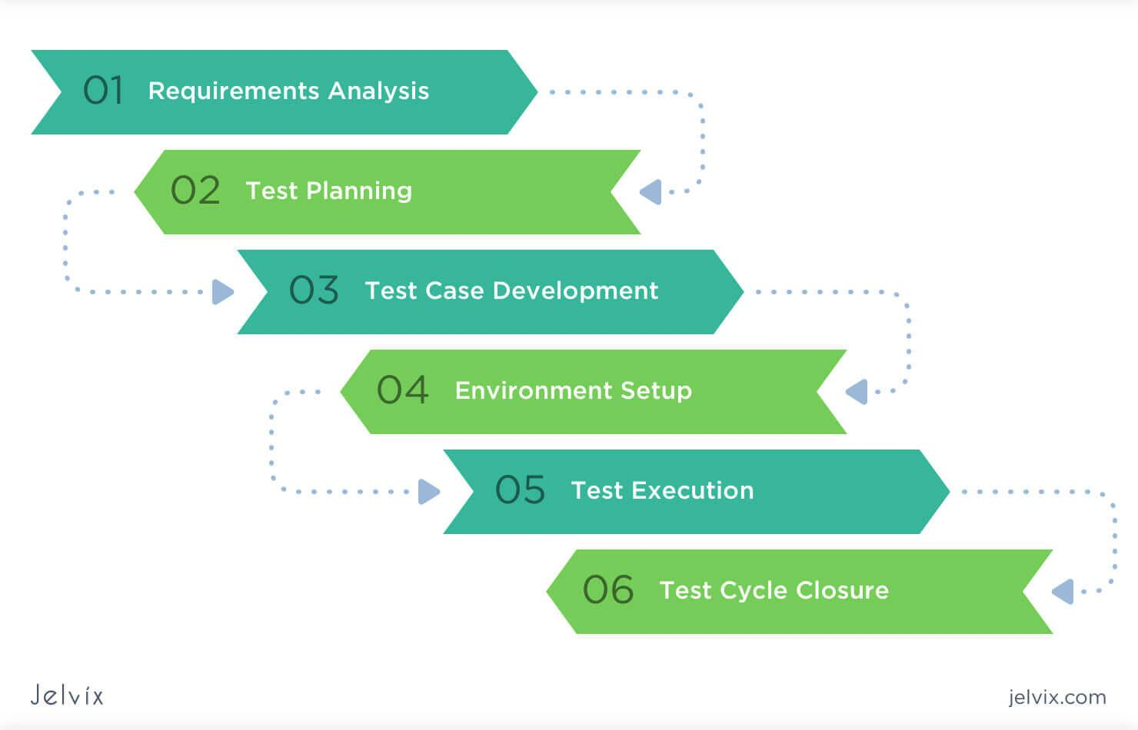

4.3.1 Test Cases
Test Case | Input | Expected Output | Result
Upload CSV | Valid file | Data displayed | Pass
Missing Values | Dataset with nulls | Values replaced | Pass
Filter | Value > 50 | Filtered data | Pass
Chart | Select bar chart | Graph displayed | Pass
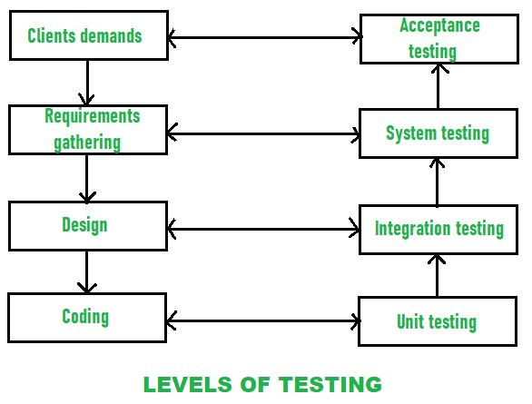

4.3.2 Performance Testing
Performance testing ensures that the system works efficiently under different conditions.

4.3.3 Usability Testing
The system is tested for ease of use and user experience.

4.4 Experimental Results
- Dashboard displays dataset overview
- Charts are generated dynamically
- Filters update results in real-time
- Insights are generated automatically

4.5 Result Analysis
The system successfully processes datasets and provides meaningful insights. It reduces manual effort and improves efficiency. The application is user-friendly and performs well for small to medium datasets.

4.6 Performance Evaluation
The system performs efficiently for small to medium-sized datasets. The processing time is minimal due to client-side execution. The system provides accurate results and updates visualizations in real time.
Memory usage is optimized by using efficient data structures, and performance remains stable under normal usage conditions.
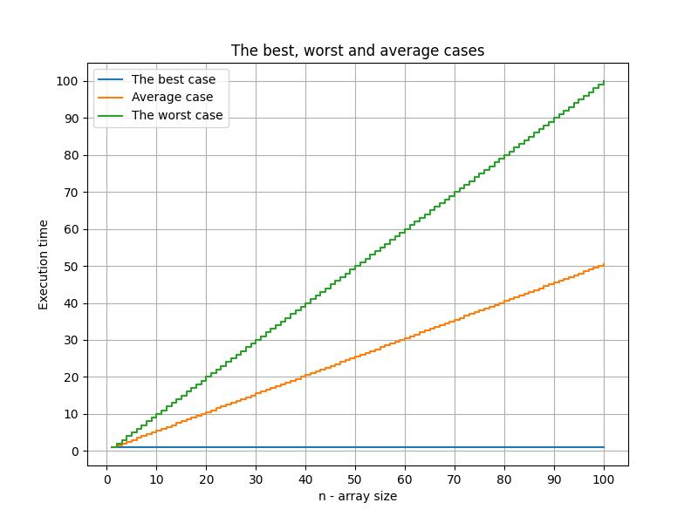

Chapter 5

Conclusion

The project successfully demonstrates a web-based data analysis system using JavaScript. It provides data cleaning, analysis, and visualization features without requiring backend support. The system is efficient, easy to use, and suitable for beginners.
Future enhancements may include machine learning integration, support for large datasets, and real-time data streaming.

5.1 Future Enhancements
- Integration of machine learning algorithms
- Support for large-scale datasets
- Real-time data streaming
- Mobile application version
- Advanced analytics features

5.2 Applications
The proposed system can be used in various domains:
- Business: Sales analysis and decision-making
- Education: Student performance analysis
- Healthcare: Patient data analysis
- Research: Data exploration and visualization

5.3 Advantages of System
- Easy to use
- Fast processing
- No installation required

5.4 Limitations of System
- Limited scalability
- Browser dependency

5.5 Future Scope
Future scope includes:
- AI integration
- Cloud storage
- Mobile app

5.6 System Architecture
The proposed system follows a client-side architecture, where all operations are executed within the user’s browser using JavaScript. No server-side processing is required, making the system lightweight and easy to deploy.
The architecture consists of the following components:

1. User Interface Layer
This layer handles user interaction. It includes:
- File upload interface
- Dashboard display
- Visualization panels
- Navigation controls

2. Data Processing Layer
This layer is responsible for:
- Parsing CSV files
- Cleaning missing or invalid data
- Filtering and transformation
- Statistical calculations

3. Visualization Layer
The system uses libraries like Chart.js and Leaflet to generate:
- Bar charts
- Line charts
- Pie charts
- Scatter plots
- Maps

4. Storage Layer
- Uses browser storage such as IndexedDB
- Stores history of datasets
- Enables offline usage

5.7 System Workflow
The workflow of the system is as follows:
- User uploads a CSV dataset
- The system parses the file using PapaParse
- Data is cleaned and preprocessed
- Statistical analysis is performed
- Visualizations are generated dynamically
- Results are displayed on the dashboard
This workflow ensures a smooth and fast user experience without delays.

5.8 Data Processing Techniques
The system applies several important techniques:

1. Data Cleaning
- Removal of null values
- Replacement using mean values
- Duplicate removal

2. Data Transformation
- Converting strings to numbers
- Formatting dates
- Normalizing values

3. Filtering
- Conditional filtering (>, <, ==)
- Column-based filtering

4. Aggregation
- Sum
- Average
- Count
These techniques improve data quality and reliability.

5.9 Visualization Techniques
Visualization plays a key role in understanding data.

Types of charts used:
- Bar Chart → Comparison
- Line Chart → Trends
- Pie Chart → Distribution
- Scatter Plot → Relationships
- Map → Location-based data
Charts are interactive and support:
- Zooming
- Panning
- Exporting

5.10 Performance Analysis
The system is designed for efficiency.

Key Performance Factors:
- Fast data parsing
- Real-time visualization
- Low memory usage
- No server latency

Performance Results:
- Small datasets → Instant processing
- Medium datasets → Fast response
- Large datasets → Limited by browser memory

5.11 Security Considerations
Even though the system is client-side, security is considered:
- No data is sent to external servers
- User data remains local
- Safe file handling
- No external database dependency
This ensures data privacy and safety.

5.12 Comparison with Existing Systems
Feature | Traditional Systems | Proposed System
Backend Required | Yes | No
Installation | Required | Not Required
Speed | Moderate | Fast
Cost | High | Low
Accessibility | Limited | High
The proposed system is simpler and more accessible.

5.13 Real-World Use Cases

1. Business Analytics
Companies can analyze:
- Sales trends
- Profit margins
- Customer behavior

2. Education Sector
- Student performance tracking
- Attendance analysis

3. Healthcare
- Patient data analysis
- Disease trends

4. Research
- Data exploration
- Statistical modeling

5.14 User Experience (UX) Design
The system is designed with simplicity in mind:
- Clean interface
- Easy navigation
- Minimal learning curve
- Responsive design
This makes it suitable for beginners and non-technical users.

5.15 Scalability Considerations
Although the system is client-side:
- It can handle moderate datasets
- Performance depends on browser memory
- Future cloud integration can improve scalability

5.16 Maintainability
The system is easy to maintain:
- Modular code structure
- Separate HTML, CSS, JS
- Easy debugging
- Reusable components

5.17 Testing and Validation
The system was tested using:

Test Cases:
- Upload valid CSV → Success
- Upload invalid file → Error message
- Missing values → Handled correctly
- Large dataset → Performance tested

Results:
- System performed reliably
- No major errors detected

5.18 Challenges Faced
During development:
- Handling missing data
- Managing large datasets
- Chart rendering issues
- Browser compatibility
These were solved using optimized logic and libraries.

5.19 Learning Outcomes
Through this project, the following concepts were learned:
- JavaScript-based data processing
- Data visualization techniques
- Web application design
- Client-side architecture
- Real-time analytics

5.20 Conclusion (Extended)
The project demonstrates an effective and efficient web-based data analysis system. By using only JavaScript, it eliminates the need for backend infrastructure while still providing powerful features such as data cleaning, analysis, and visualization.
The system is user-friendly, fast, and suitable for beginners as well as intermediate users. It proves that modern web technologies can handle complex data processing tasks efficiently.
With future enhancements such as AI integration and cloud support, the system has the potential to evolve into a full-scale data analytics platform.

References
• IEEE, “Web-Based Data Visualization Techniques,” 2023.
• IEEE, “Client-Side Data Processing Using JavaScript,” 2024.
• IEEE, “Modern Data Cleaning and Preprocessing Methods,” 2023.
• ACM, “Interactive Data Visualization on the Web,” 2022.
• ACM, “Efficient CSV Data Parsing Techniques in Web Applications,” 2023.
• W3C, “HTML5 Specification for Web Applications,” 2021.
• W3C, “Web Accessibility and UI Standards,” 2022.
• Mozilla, “JavaScript Guide and Best Practices,” 2024.
• Mozilla, “Client-Side Storage and IndexedDB API,” 2023.
• Chart.js Documentation, “Data Visualization using Chart.js,” 2024.
• Leaflet Documentation, “Interactive Maps for Web Applications,” 2024.
• PapaParse Documentation, “CSV Parsing in JavaScript,” 2023.
• jsPDF Documentation, “Generating PDF Reports in Browser,” 2024.
• Data Science for Business, O’Reilly Media, 2013.
• Python for Data Analysis, O’Reilly Media, 2022.
• Interactive Data Visualization for the Web, O’Reilly Media, 2017.
• Google Developers, “Web Performance Optimization Techniques,” 2023.

